SHUBHANK KATAREY
(PGP_DSBA)
PREDICTIVE MODELLING

Problem 1: Linear Regression

Problem Statement:

You are hired by a company Gem Stones co ltd, which is a cubic zirconia manufacturer. You are provided with the dataset containing the prices and other attributes of almost 27,000 cubic zirconia (which is an inexpensive diamond alternative with many of the same qualities as a diamond). The company is earning different profits on different prize slots. You have to help the company in predicting the price for the stone on the bases of the details given in the dataset so it can distinguish between higher profitable stones and lower profitable stones so as to have better profit share. Also, provide them with the best 5 attributes that are most important.

Data Dictionary:

Carat: Carat weight of the cubic zirconia.

Cut: Describe the cut quality of the cubic zirconia. Quality is increasing order Fair, Good, Very Good, Premium, Ideal.

Color: Color of the cubic zirconia with D being the best and J the worst.

Clarity: cubic zirconia Clarity refers to the absence of the Inclusions and Blemishes. (In order from Best to Worst, IF = flawless, l1= level 1 inclusion) IF, VVS1, VVS2, VS1, VS2, Sl1, Sl2, l1

Depth: The Height of cubic zirconia, measured from the Culet to the table, divided by its average Girdle Diameter.

Table: The Width of the cubic zirconia's Table expressed as a Percentage of its Average Diameter.

Price: The Price of the cubic zirconia.

X: Length of the cubic zirconia in mm.

Y: Width of the cubic zirconia in mm.

Z: Height of the cubic zirconia in mm.

1.1. Read the data and do exploratory data analysis. Describe the data briefly. (Check the null values, Data types, shape, EDA). Perform Univariate and Bivariate Analysis.

READING THE DATASET:

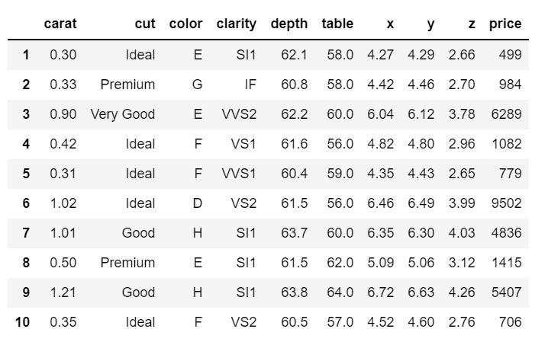

CHECKING THE SHAPE:

Number of columns: 26967

Number of Rows: 10

DESCRIBING THE DATASET:

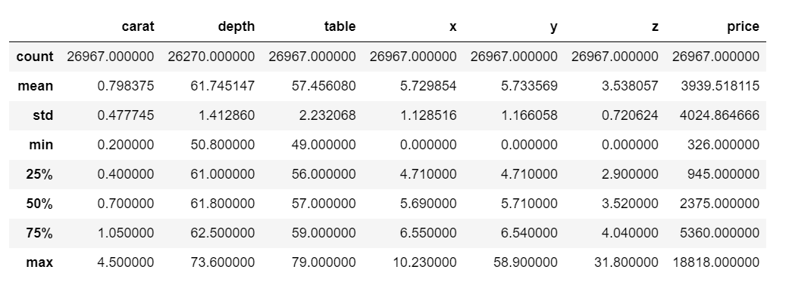

We can see minimum price is 326 and maximum is 18818.

Maximum carat is 4.50 and minimum is 0.20.

The minimum values of x, y and z is zero, which is not possible because dimensions cannot be in zeros. So we need to correct those values. We will do it later.

LET US CHECK SOME MORE INFO:

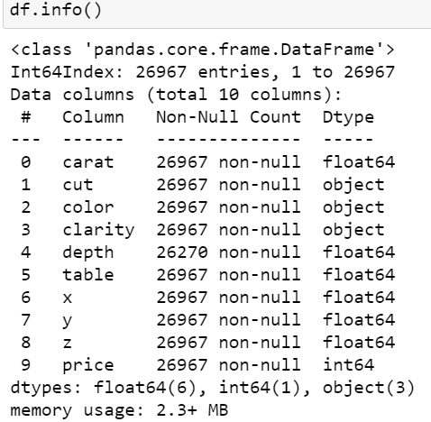

There are total 10 columns and 26967 rows.
There are non-null values present only in ‘depth’ column.
There are 6 float types, 1 integer type and 3 object types’ columns in the dataset.

ARE THERE ANY NULL VALUES? LET SEE:

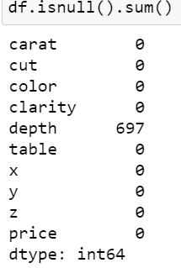

697 null values are present in depth column.

CHECK FOR DUPLICATES:
There are 34 duplicate records found. Let's remove it from the dataset.
After dropping duplicates, there are only 26933 columns left.

LET’S CHECK THE OBJECT DATATYPES:
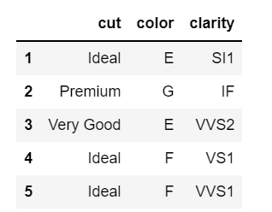
Cut, color and clarity are the columns with the object data type.

SOME MORE DETAILS ABOUT OBJECT DATATYPE COLUMNS:

Number of unique values in "cut" variable: 5

Those unique values are: ['Ideal' 'Premium' 'Very Good' 'Good' 'Fair']

Value Counts:

Ideal 10805

Premium 6886

Very Good 6027

Good 2435

Fair 780

Name: cut, dtype: int64

_____________________________________________

Number of unique values in "color" variable: 7

Those unique values are: ['E' 'G' 'F' 'D' 'H' 'J' 'I']

Value Counts:

D 3341

E 4916

F 4723

G 5653

H 4095

I 2765

J 1440

Name: color, dtype: int64

_____________________________________________

Number of unique values in "clarity" variable: 8

Those unique values are: ['SI1' 'IF' 'VVS2' 'VS1' 'VVS1' 'VS2' 'SI2' 'I1']

Value Counts:

SI1 6565

VS2 6093

SI2 4564

VS1 4087

VVS2 2530

VVS1 1839

IF 891

I1 364

Name: clarity, dtype: int64

'Ideal' quality stones are in majority and 'Fair' quality stones are less.

HISTOGRAM

Creating the histogram for Carat, depth and price.

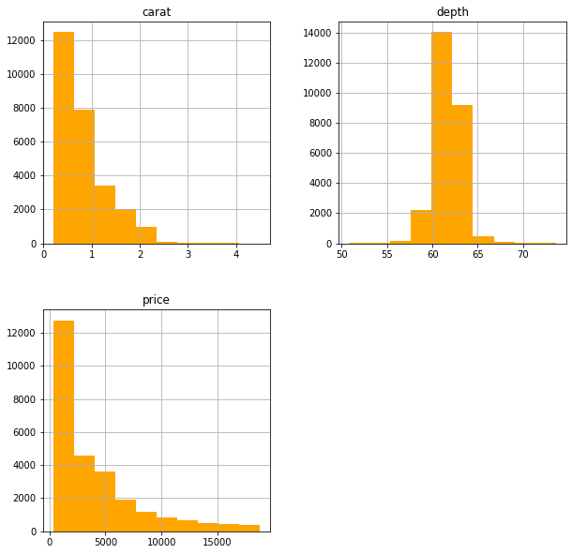

COUNTPLOT

Let’s check the count of cut:

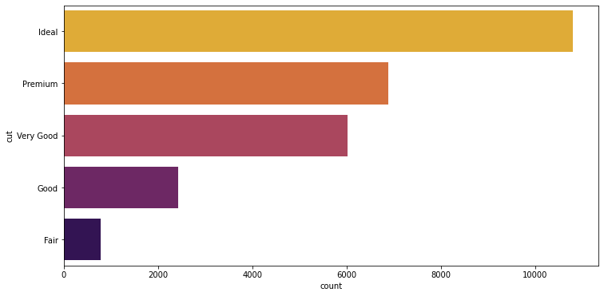

Ideal cut has the maximum count while fair cut has the minimum count.

Let’s check the count of different available colors:

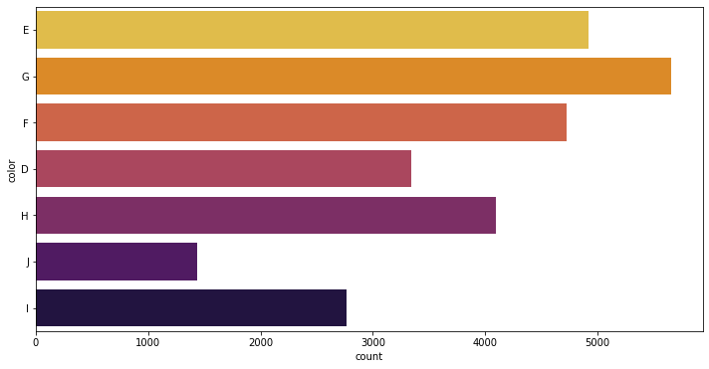

The stone of Color ‘G’ has the maximum count and of color ‘J’ is the minimum count.

Let’s check the count of clarity:

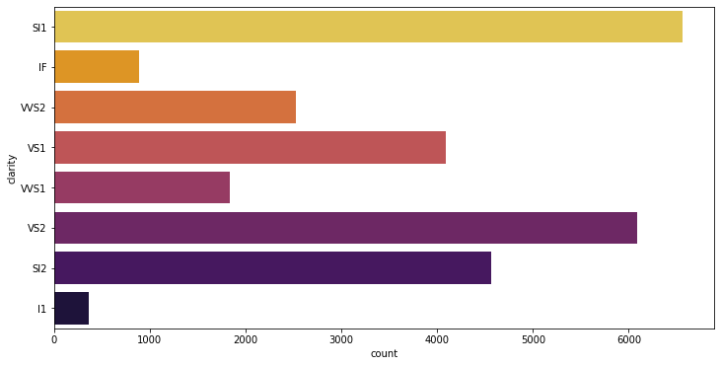

DESCRIPTION ABOUT PRICE:

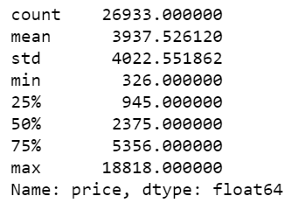

The minimum price of the stone is 326 and the maximum price is 18818.

Mean is 3937.5

75% of the stones have the price value around 5356.

BARPLOT

Price against Clarity:

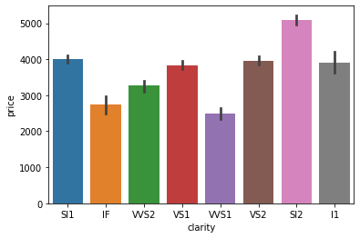

Price against cut:

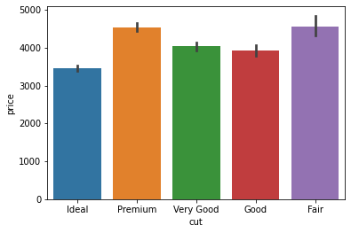

Price against color:

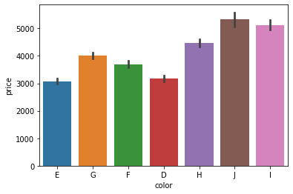

BOXPLOT

Let's check the outliers in cut, color, clarity with respect to price variable:

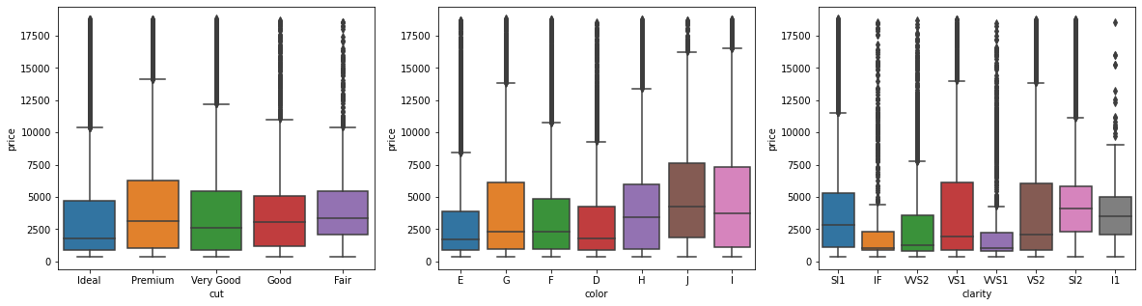

Outliers are present in all of the categorical variables.

Let's check the Outliers in all the features:

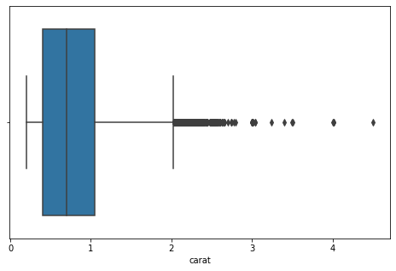

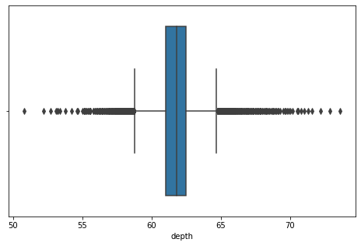

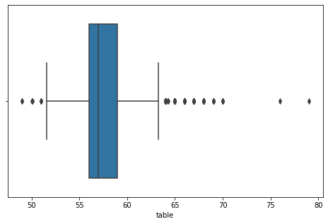

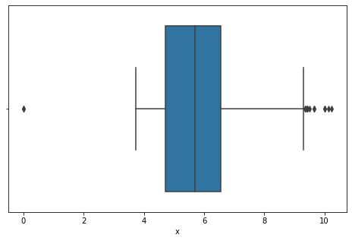

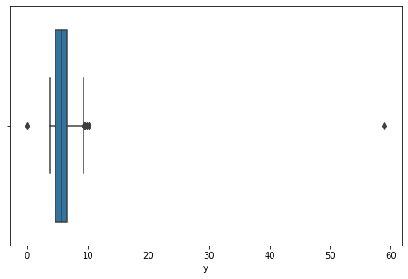

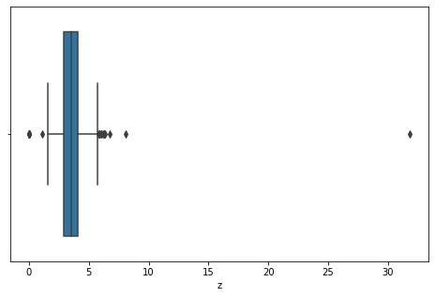

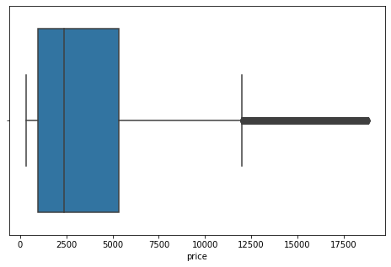

PAIRPLOT

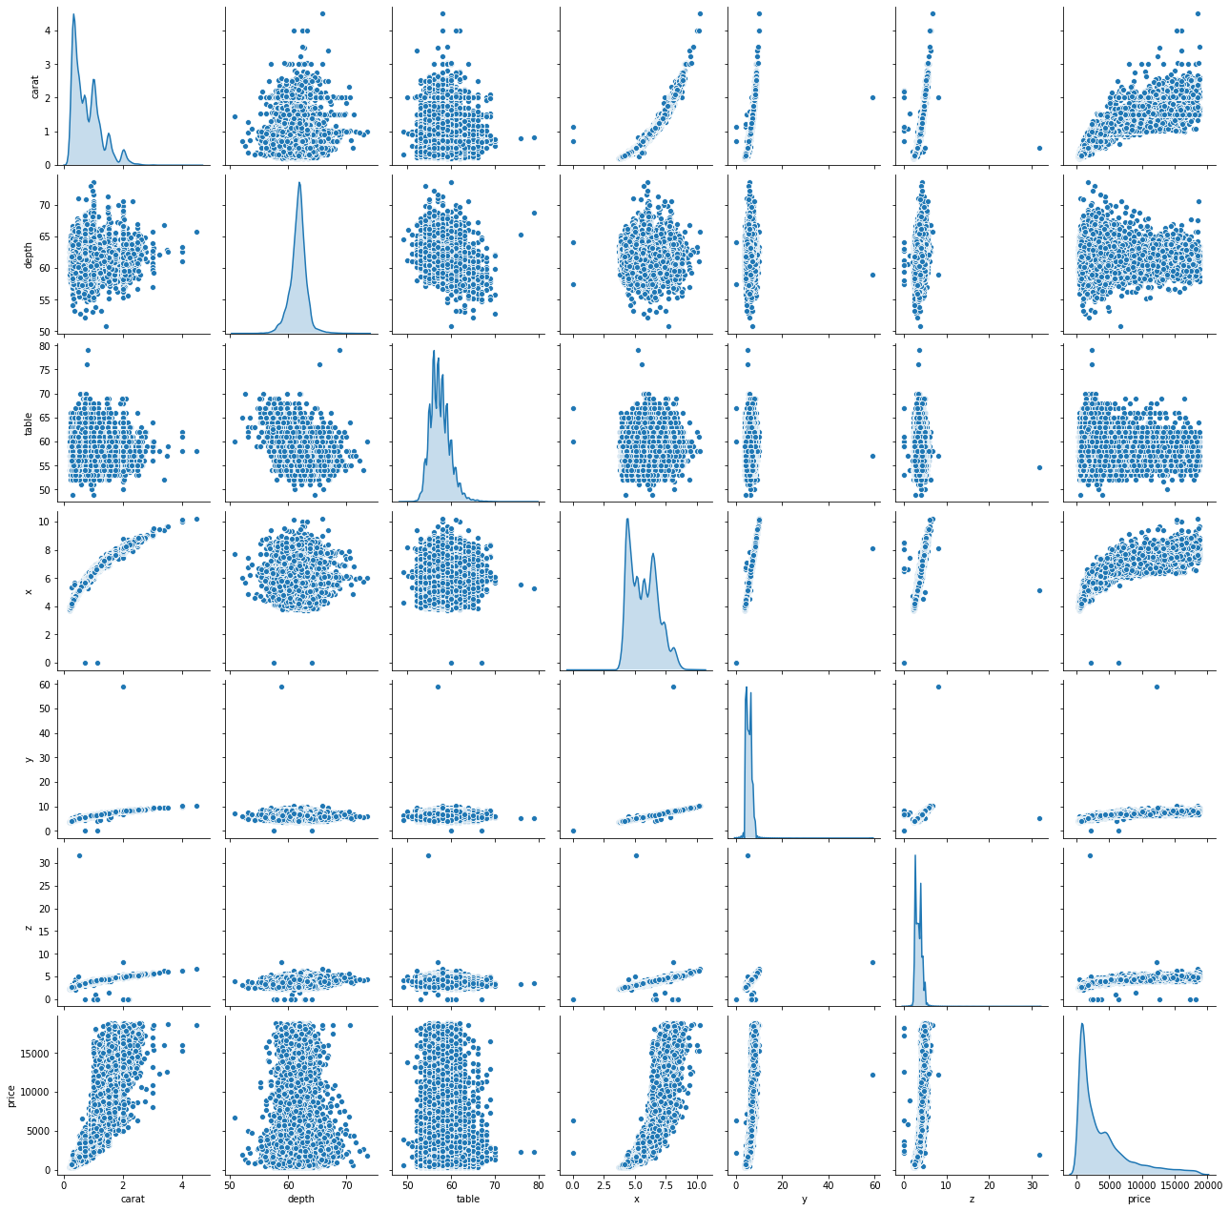

CORRELATION AND HEATMAP

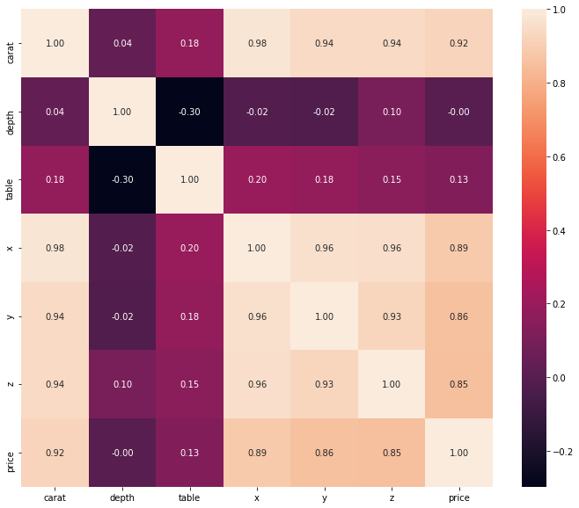

We can see multicollinearity in the data.

SCATTER PLOT

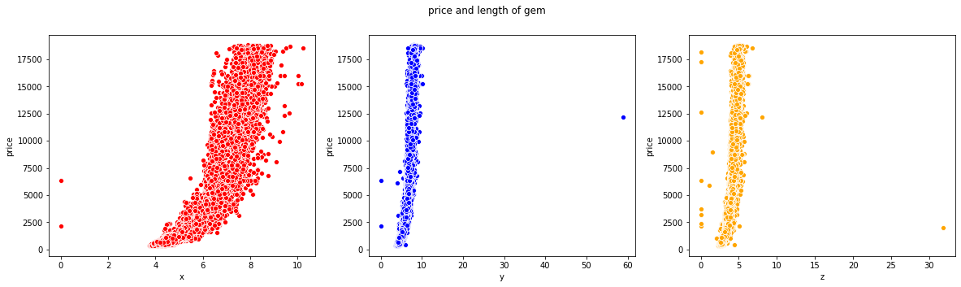

We can see that dimensions does not affect much on price, so we can remove those columns.

1.2 Impute null values if present, also check for the values which are equal to zero. Do they have any meaning or do we need to change them or drop them? Do you think scaling is necessary in this case?

There are 697 null values in ‘depth’, so imputing those places with mean value of depth.

Again checking the null values.

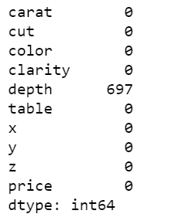

Now, there are no null values present in the dataset.

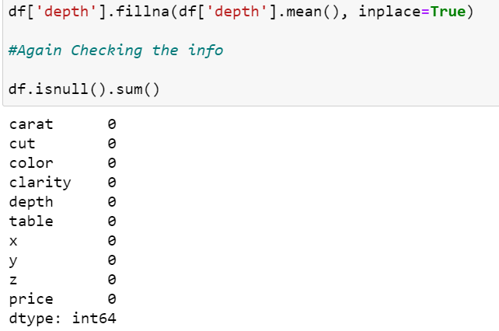

Checking and dropping the zeros from X, Y, Z columns if available.
Let's check the location of presence of zeros in x, y, z columns.
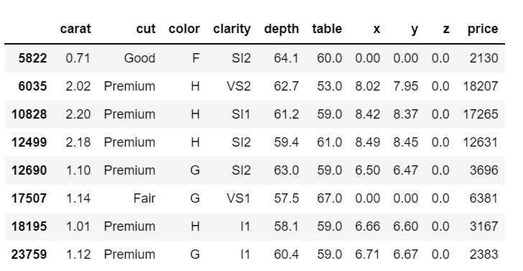

Scaling the data:

Using standard scaler: Scaling the integer columns by fit_transform.

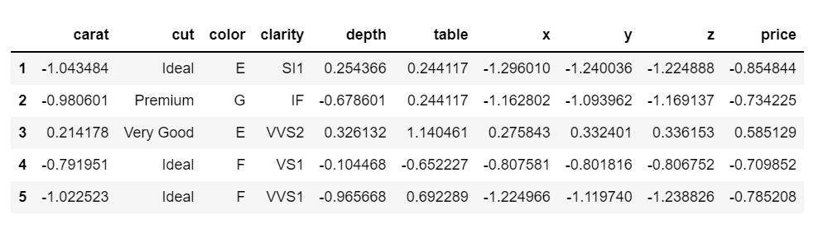

OUTLIERS TREATMENT

We have to remove the outliers from the data.

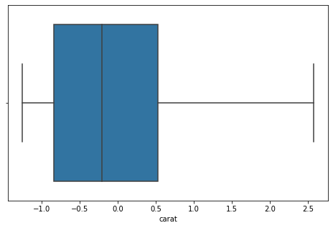

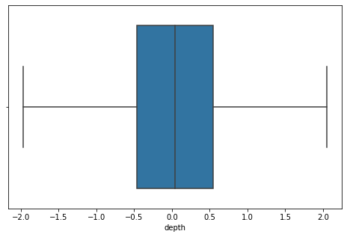

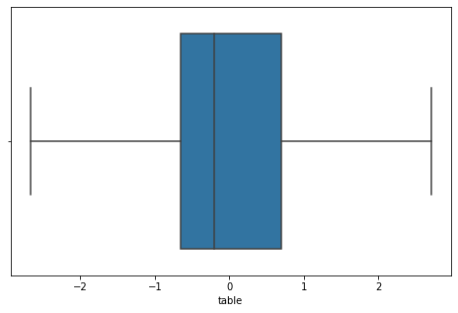

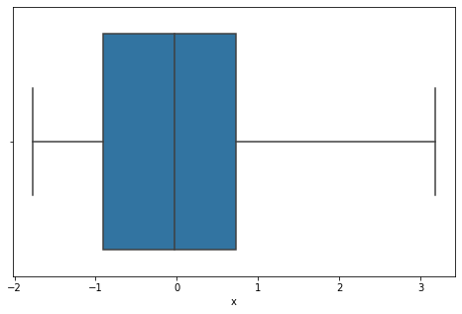

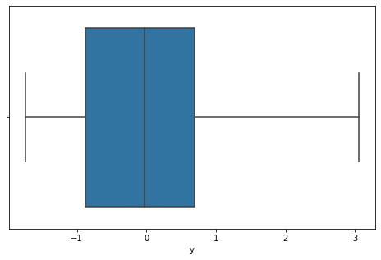

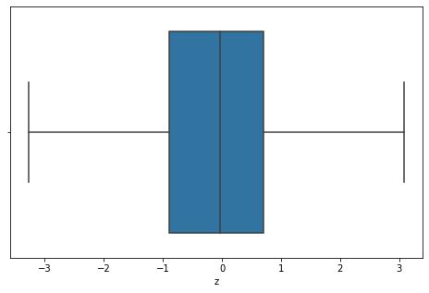

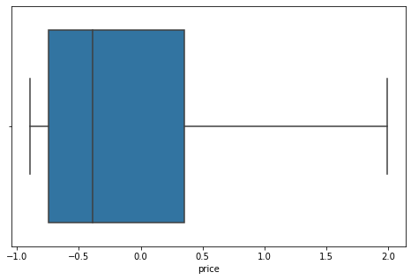

1.3 Encode the data (having string values) for Modelling. Data Split: Split the data into train and test (70:30). Apply linear regression. Performance Metrics: Check the performance of Predictions on Train and Test sets using Rsquare, RMSE.

First we will convert categorical to dummy variables and also renaming the column ‘cut_Very Good’ to ‘cut_Very_Good’.

Linear Regression Model does not accept categorical values, the Dummies have been encoded.

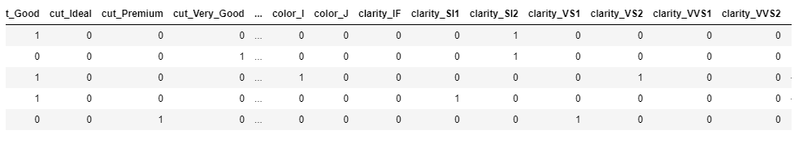

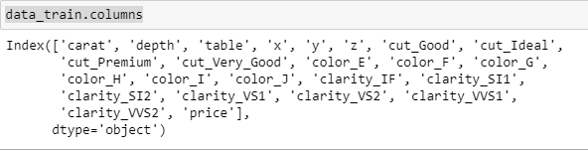

Now, assigning the target variable ‘price’ to ‘y’ and then splitting the dataset into Train and Test set in 70:30 ratio and applying the Linear Regression model.

Then we will fit the X_train and y_train into the model. After that, we will check the score on train and test data.

The model score for train data is 0.9404719027464119 using reg_model.score (X_train, y_train).

The model score for test data is 0.9416169664411843 using reg_model.score (X_test, y_test).

Now, checking Root mean square error (RMSE) on train and test data:

RMSE on train data is 0.20984203003055799.

RMSE on test data is 0.20942733183439705.

Checking the coefficients:

Coefficient for carat is 1.091608986444096

Coefficient for depth is 0.004292589689086406

Coefficient for table is -0.01280995363087446

Coefficient for x is -0.3297283160277515

Coefficient for y is 0.31326746642933856

Coefficient for z is -0.11428048662800115

Coefficient for cut_Good is 0.09632120352750682

Coefficient for cut_Ideal is 0.1566526304064449

Coefficient for cut_Premium is 0.1488898790105733

Coefficient for cut_Very_Good is 0.12494507083633381

Coefficient for color_E is -0.04697340540558105

Coefficient for color_F is -0.05750774333969632

Coefficient for color_G is -0.10223606541857169

Coefficient for color_H is -0.20679844309213313

Coefficient for color_I is -0.3308004746003582

Coefficient for color_J is -0.4629825913578346

Coefficient for clarity_IF is 0.9936103167577837

Coefficient for clarity_SI1 is 0.6306802090826207

Coefficient for clarity_SI2 is 0.42581742996624716

Coefficient for clarity_VS1 is 0.8344180308840299

Coefficient for clarity_VS2 is 0.7640466334789668

Coefficient for clarity_VVS1 is 0.9393141121734576

Coefficient for clarity_VVS2 is 0.9367999621686632

CHECKING INTERCEPT:

The intercept for our model is -0.7571488566897918.

Now, after concatenate X and y into a single DataFrame, let’s look at the columns in train data.

Index (['carat', 'depth', 'table', 'x', 'y', 'z', 'cut_Good', 'cut_Ideal', 'cut_Premium',

'cut_Very_Good', 'color_E', 'color_F', 'color_G', 'color_H', 'color_I', 'color_J', 'clarity_IF',

'clarity_SI1', 'clarity_SI2', 'clarity_VS1', 'clarity_VS2', 'clarity_VVS1', 'clarity_VVS2', 'price'],

dtype='object')

expr = 'price ~ carat + depth + table + x+ y + z + cut_Good + cut_Ideal + cut_Premium + cut_Very_Good + color_E + color_F + color_G + color_H + color_I + color_J + clarity_IF + clarity_SI1 + clarity_SI2 + clarity_VS1 + clarity_VS2 + clarity_VVS1 + clarity_VVS2'

lm1 parameters:

Intercept -0.757149

carat 1.091609

depth 0.004293

table -0.012810

x -0.329728

y 0.313267

z -0.114280

cut_Good 0.096321

cut_Ideal 0.156653

cut_Premium 0.148890

cut_Very_Good 0.124945

color_E -0.046973

color_F -0.057508

color_G -0.102236

color_H -0.206798

color_I -0.330800

color_J -0.462983

clarity_IF 0.993610

clarity_SI1 0.630680

clarity_SI2 0.425817

clarity_VS1 0.834418

clarity_VS2 0.764047

clarity_VVS1 0.939314

clarity_VVS2 0.936800

dtype: float64

Best parameters summary:

OLS Regression Results

==============================================================================

Dep. Variable: price R-squared: 0.940

Model: OLS Adj. R-squared: 0.940

Method: Least Squares F-statistic: 1.293e+04

Date: Sat, 31 Jul 2021 Prob (F-statistic): 0.00

Time: 20:48:47 Log-Likelihood: 2685.0

No. Observations: 18847 AIC: -5322.

Df Residuals: 18823 BIC: -5134.

Df Model: 23

Covariance Type: nonrobust

=================================================================================

coef std err t P>|t| [0.025 0.975]

---------------------------------------------------------------------------------

Intercept -0.7571 0.016 -46.528 0.000 -0.789 -0.725

carat 1.0916 0.009 118.886 0.000 1.074 1.110

depth 0.0043 0.004 1.184 0.237 -0.003 0.011

table -0.0128 0.002 -6.021 0.000 -0.017 -0.009

x -0.3297 0.038 -8.626 0.000 -0.405 -0.255

y 0.3133 0.040 7.835 0.000 0.235 0.392

z -0.1143 0.023 -4.886 0.000 -0.160 -0.068

cut_Good 0.0963 0.011 8.796 0.000 0.075 0.118

cut_Ideal 0.1567 0.011 14.701 0.000 0.136 0.178

cut_Premium 0.1489 0.010 14.582 0.000 0.129 0.169

cut_Very_Good 0.1249 0.011 11.898 0.000 0.104 0.146

color_E -0.0470 0.006 -8.318 0.000 -0.058 -0.036

color_F -0.0575 0.006 -10.046 0.000 -0.069 -0.046

color_G -0.1022 0.006 -18.267 0.000 -0.113 -0.091

color_H -0.2068 0.006 -34.647 0.000 -0.218 -0.195

color_I -0.3308 0.007 -49.715 0.000 -0.344 -0.318

color_J -0.4630 0.008 -56.819 0.000 -0.479 -0.447

clarity_IF 0.9936 0.016 61.555 0.000 0.962 1.025

clarity_SI1 0.6307 0.014 45.631 0.000 0.604 0.658

clarity_SI2 0.4258 0.014 30.639 0.000 0.399 0.453

clarity_VS1 0.8344 0.014 59.087 0.000 0.807 0.862

clarity_VS2 0.7640 0.014 54.934 0.000 0.737 0.791

clarity_VVS1 0.9393 0.015 62.758 0.000 0.910 0.969

clarity_VVS2 0.9368 0.015 64.387 0.000 0.908 0.965

==============================================================================

Omnibus: 4642.691 Durbin-Watson: 2.002

Prob(Omnibus): 0.000 Jarque-Bera (JB): 17342.712

Skew: 1.197 Prob(JB): 0.00

Kurtosis: 7.043 Cond. No. 67.8

==============================================================================

Warnings:

[1] Standard Errors assume that the covariance matrix of the errors is correctly specified.

Calculate MSE:

Mean Square Error: 0.04403367756734561.

Root mean square error: 0.209842030030558

Model score: 0.9416169664411843

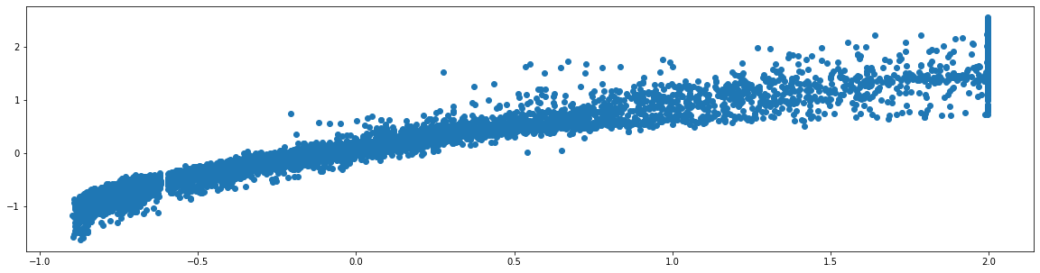

(-0.76) * Intercept + (1.09) * carat + (0.0) * depth + (-0.01) * table + (-0.33) * x + (0.31) * y + (-0.11) * z + (0.1) * cut_Good + (0.16) * cut_Ideal + (0.15) * cut_Premium + (0.12) * cut_Very_Good + (-0.05) * color_E + (-0.06) * color_F + (-0.1) * color_G + (-0.21) * color_H + (-0.33) * color_I + (-0.46) * color_J + (0.99) * clarity_IF + (0.63) * clarity_SI1 + (0.43) * clarity_SI2 + (0.83) * clarity_VS1 + (0.76) * clarity_VS2 + (0.94) * clarity_VVS1 + (0.94) * clarity_VVS2.

1.4 Inference: Basis on these predictions, what are the business insights and recommendations.

Insights and Observations:

The most preferred cut chosen by the customers is the Ideal cut, because it is cheaper than the other available cuts.

We can also see that the reason behind the 'Fair' being the least preferred is its price.

The quality of Fair type cut is low and price is also high.

According to the given information, D being the best color while J being the worst but still it is most costly among all of them.

The most preferred color is G, average priced.

In terms of clarity, VS2 seems to be most chosen by the customers and SI2 seems to be the costliest clarity stone.

We have also observed from the pair plot that with the increase in carat, the price is also increasing.

However, the dimensions of the stone does not affect much on the price of the stone.

Multicollinearity also present in the data.

Similarly, the company is gaining profits due to the colors H and I, also company is building profits from the ideal, premium and very_good types of cut out of 5 available cuts.

Recommendations:

1) TOP LEVEL CUT. Based on the above few observations from the concluded result, we can say that cut and clarity holds the power of growing the profits for the company and that is the biggest benefit, because the upper level cuts like Ideal cut, premium cut and the very_good type of cut captures the higher contribution towards the company's growth, and so I recommend that we should display and prioritize those 3 cuts and company should make the best marketing strategy to boost the sales of these stones.

2) BETTER THE QUALITY, MORE THE PROFIT. Also, I can see that the clarity of the stones holds the power to boost the profit for the company. So I recommend that the company should focus more on the stone's clarity, because better the clarity, more the profit.

3) FOCUS LESS ON THE DIMENSIONS, MORE ON CARAT: Length, width and Height of the stones does not affect much on the price of the stones, but carat of the stones bring the profits. So I recommend that company should ask the production team to get the best of the quality to its stones, so that profit would be better in such cases.

_ THE END __

Problem 2: Logistic Regression and LDA

Problem Statement:

You are hired by a tour and travel agency which deals in selling holiday packages. You are provided details of 872 employees of a company. Among these employees, some opted for the package and some didn't. You have to help the company in predicting whether an employee will opt for the package or not on the basis of the information given in the data set. Also, find out the important factors on the basis of which the company will focus on particular employees to sell their packages.

Data Dictionary:

Holiday_Package: Opted for Holiday Package yes/no?

Salary: Employee salary

age: Age in years

edu: Years of formal education

no_young_children: The number of young children (younger than 7 years)

no_older_children: Number of older children

foreign: foreigner Yes/No

2.1 Data Ingestion: Read the dataset. Do the descriptive statistics and do null value condition check, write an inference on it. Perform Univariate and Bivariate Analysis. Do exploratory data analysis.

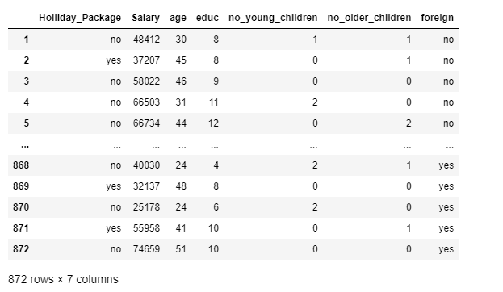

Let's rename the column first for better readability:

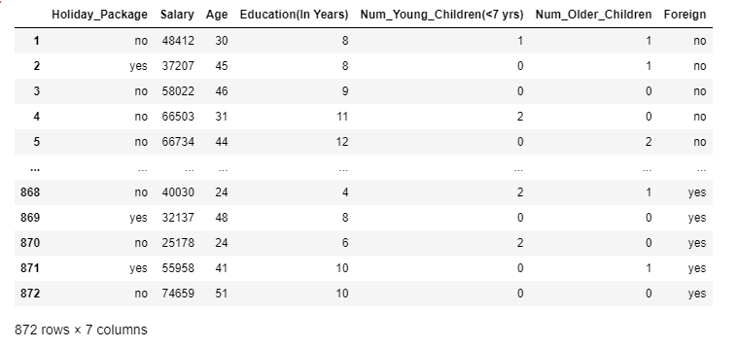

LET’S CHECK THE SHAPE

No. of rows: 872

No. of columns: 7

DESCRIPTION

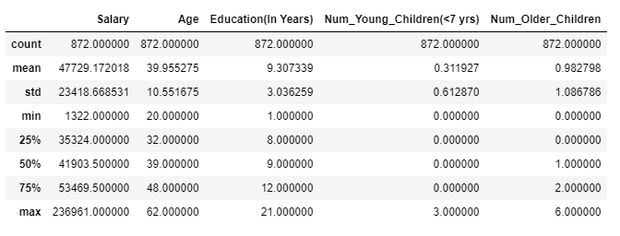

The maximum age is 62 and the minimum age is 20.

SOME MORE INFO ABOUT THE DATA

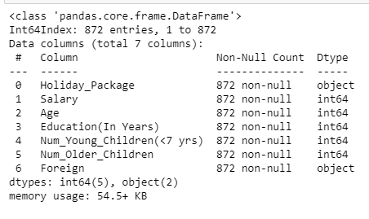

There are no non-null values. There are 2 columns with object datatype and 5 columns with integer datatype.

CHECKING ANY MISSING VALUES

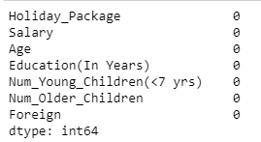

CHECKING DUPLICATES IF ANY: No duplicates found.

Value Counts in object data type columns:

No 471

Yes 401

Name: Holiday_Package, dtype: int64

No 656

Yes 216

Name: Foreign, dtype: int64

COUNTPLOTS

1. HOLIDAY_PACKAGE:

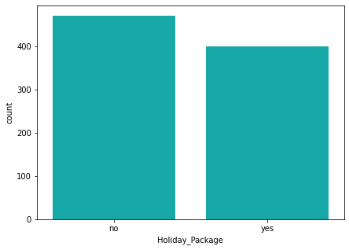

2. FOREIGN:

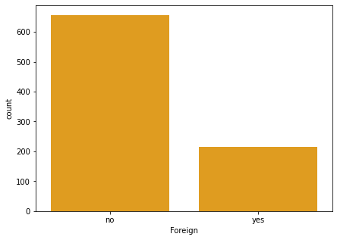

LET’S CHECK FOR OUTLIERS USING BOXPLOT:

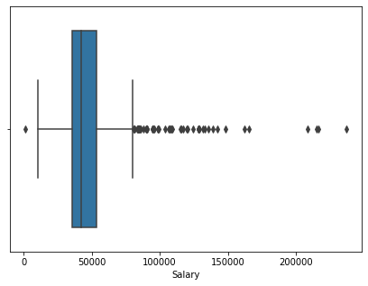

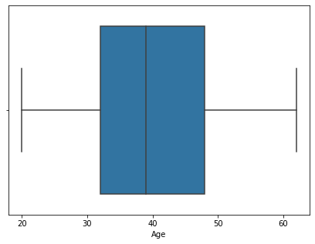

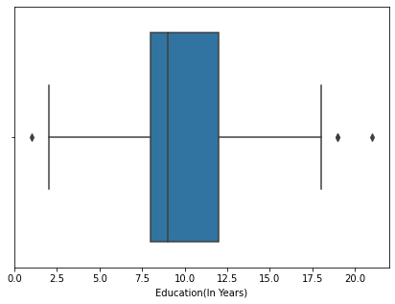

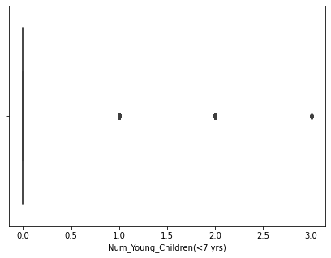

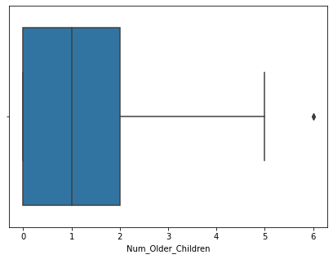

TREATING OUTLIERS: We will only treat outliers from 'Salary' and 'Education'. In all other features the outlier values are not very far from the median.

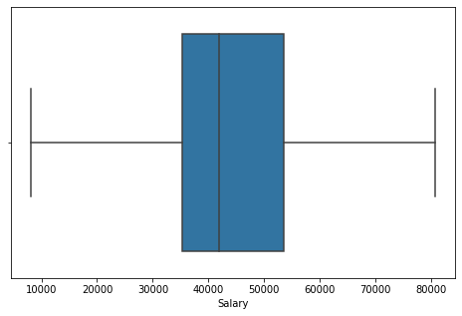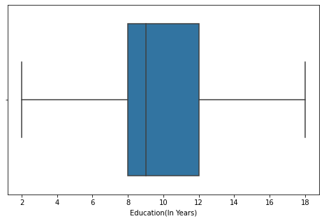

Now Outliers are removed from the above columns.

CATPLOTS

Catplot for 'foreign' with respect to 'Salary':

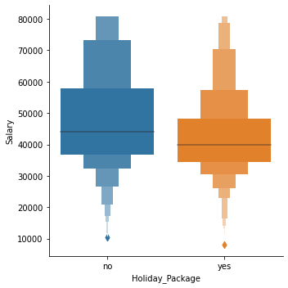

As per the above plot we can see that the non-foreigner employees earns more salary than the foreigner employees.

Catplot for 'Holiday_Package' with respect to 'Age':

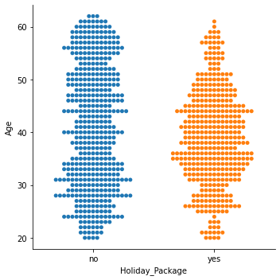

Employees whose age is 30 to 50 opt more for holiday packages.

Aged employees whose age is above 50 does not prefer to go for holidays hence not opting for holiday packages.

Holiday vs Years of Education:

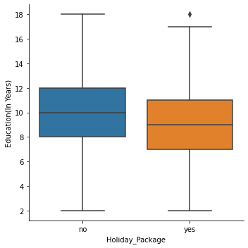

Employees whose years of education is between 7.5 to 11 years opt for holiday packages.

PAIRPLOT:

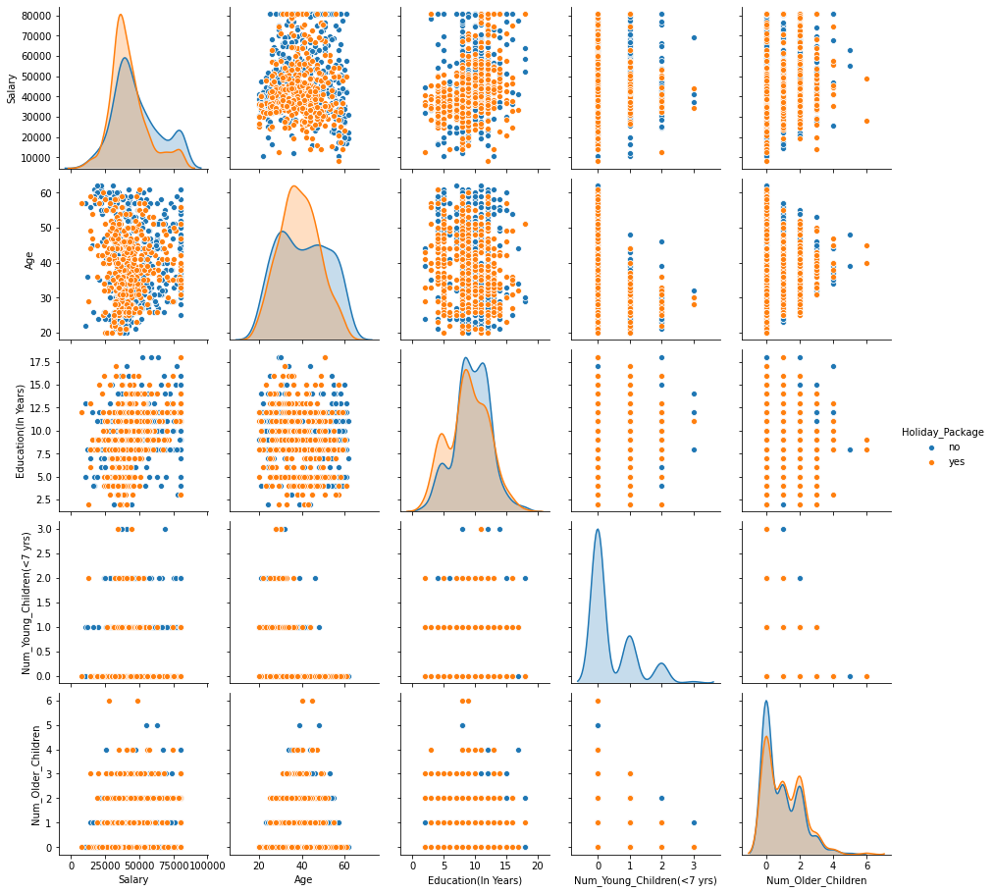

HEATMAP AND CORRELATION

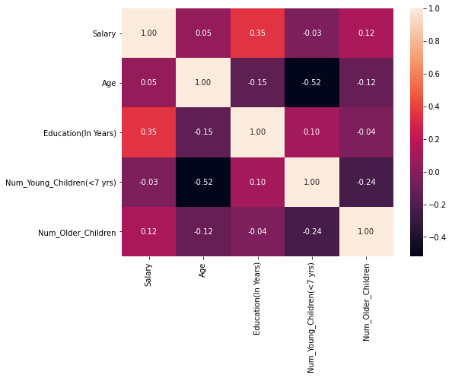

There isn't any strong correlation in the data.

2.2 Do not scale the data. Encode the data (having string values) for Modelling. Data Split: Split the data into train and test (70:30). Apply Logistic Regression and LDA (linear discriminant analysis).

Copied the original dataset into df.

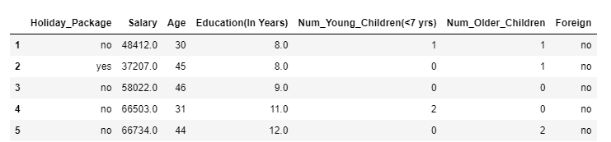

GET DUMMIES

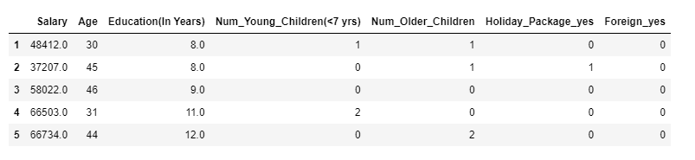

Shape and columns of dummy_df: There are 872 rows and 7 columns.

Columns:

Index (['Salary', 'Age', ‘Education (In Years)', 'Num_Young_Children (<7 yrs)',

'Num_Older_Children', 'Holiday_Package_yes', 'Foreign_yes'],

dtype='object')

Splitting into train and test set

Holiday_Package_yes is the Target variable.

Assigning the target variable to ‘y’

Let's now build the Logistic Regression Model:

We are making some adjustments to the parameters in the Logistic Regression Class to get a better accuracy.

We will use GridSearchCV for getting the best parameters for the model.

model = LogisticRegression(max_iter=100000,n_jobs=2)

grid_search=GridSearchCV (estimator = model, param_grid = grid, cv = 3,n_jobs=-1,scoring='f1')

Fit the Logistic Regression model:

grid_search.fit(X_train, y_train)

Getting the best parameters and best grid estimators:

Best Parameters: {'penalty': 'l1', 'solver': 'liblinear', 'tol': 1e-06}

Now, we are getting the best model using best parameters and best estimators.

LogisticRegression (max_iter=100000, n_jobs=2, penalty='l1', solver='liblinear', tol=1e-06)

Predicting on Training and Test dataset:

ytrain_predict = best_model.predict(X_train)

ytest_predict = best_model.predict(X_test)

Getting the probabilities on the test set:

ytest_predict_prob = best_model.predict_proba(X_test)

Checking the head from the predicted probability:

 | 0 | 1
0 | 0.671228 | 0.328772
1 | 0.560763 | 0.439237
2 | 0.684892 | 0.315108
3 | 0.510392 | 0.489608
4 | 0.560310 | 0.439690
5 | 0.345337 | 0.654663
6 | 0.573157 | 0.426843
7 | 0.303291 | 0.696709
8 | 0.386480 | 0.613520
9 | 0.633587 | 0.366413

Confusion Matrix and Classification Report on the Training Data:

Confusion matrix on the training data:

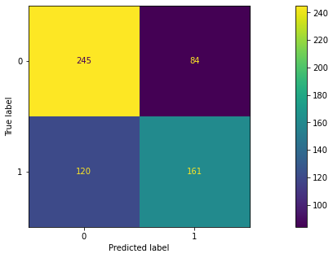

precision recall f1-score support

0 0.67 0.74 0.71 329

1 0.66 0.57 0.61 281

accuracy 0.67 610

macro avg 0.66 0.66 0.66 610

weighted avg 0.66 0.67 0.66 610

Confusion Matrix and Classification Report on Testing Data:

Confusion matrix on the test data:

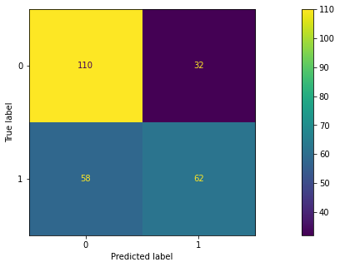

precision recall f1-score support

0 0.65 0.77 0.71 142

1 0.66 0.52 0.58 120

accuracy 0.66 262

macro avg 0.66 0.65 0.64 262

weighted avg 0.66 0.66 0.65 262

MODEL EVALUATION:

Accuracy score for training data: 0.6655737704918033

AUC: 0.733

ROC Curve:

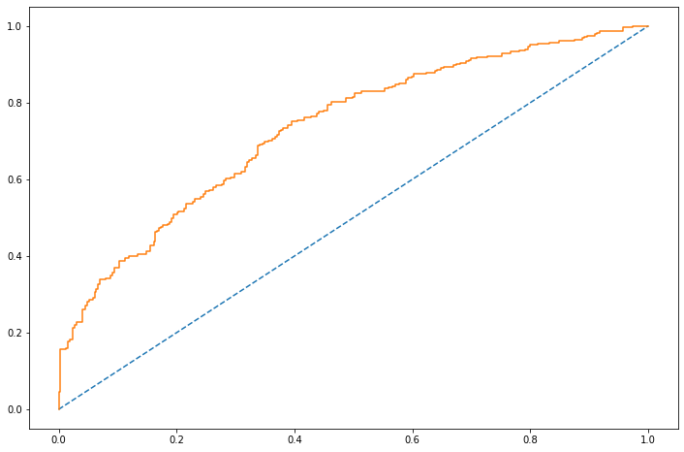

Accuracy score for test data: 0.6564885496183206

AUC: 0.715

ROC Curve:

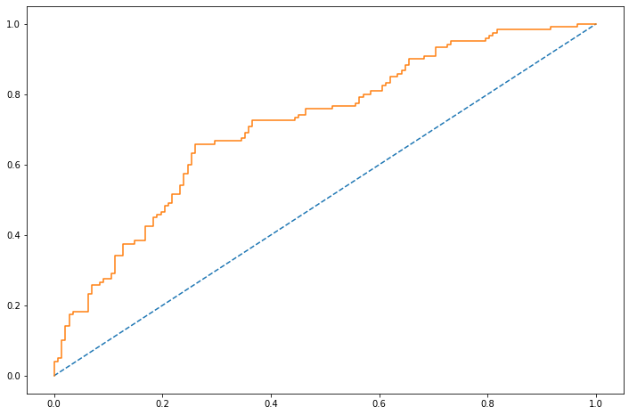

Linear Discriminant Analysis (LDA)

Reading and Loading the dataset again.

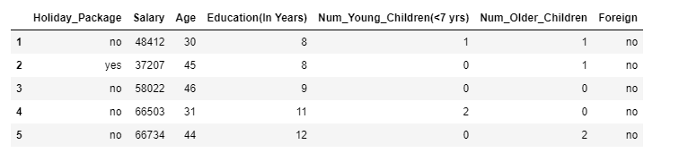

We have checked that there are no null values and we have already removed the duplicates from the data.

CHECKING THE OUTLIERS

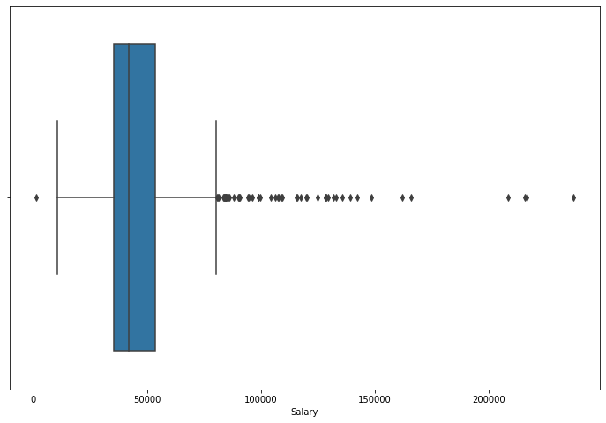

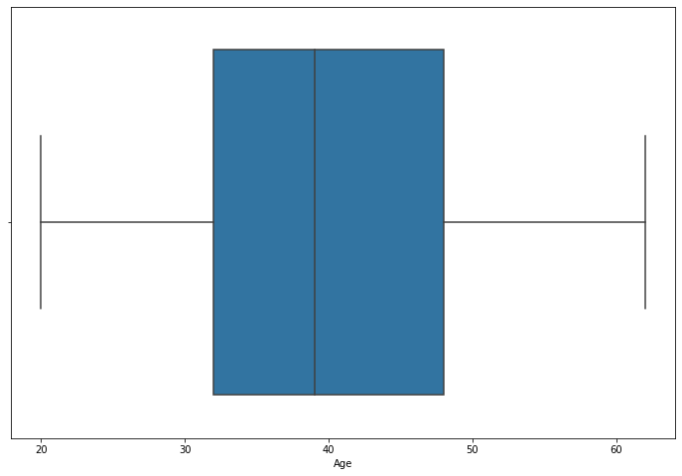

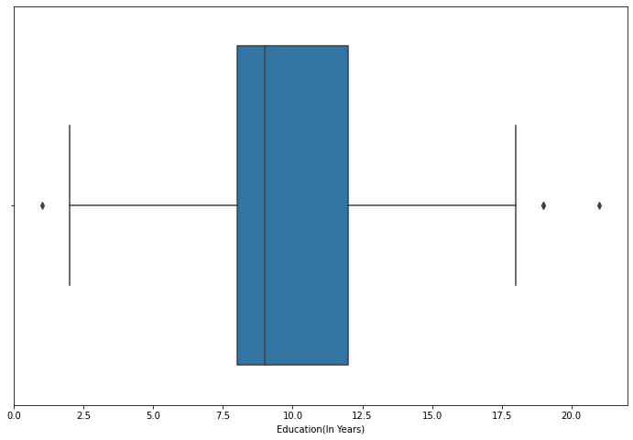

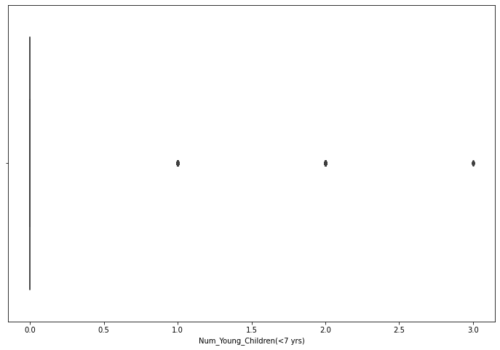

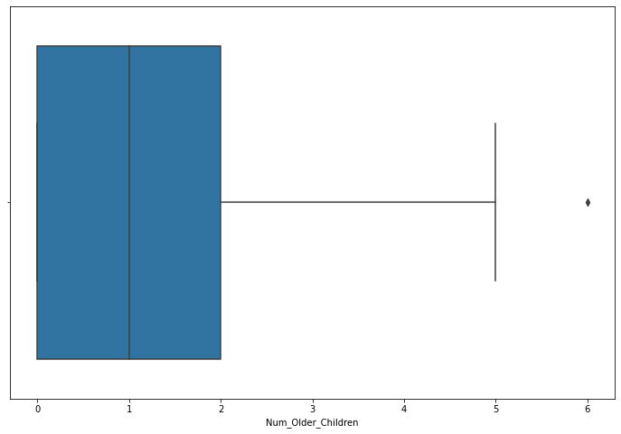

AFTER TREATING OUTLIERS

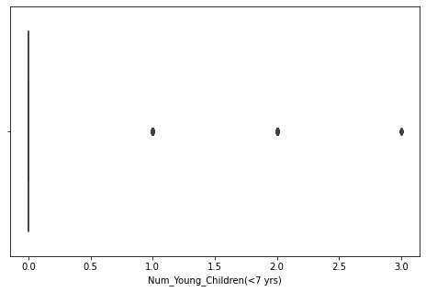

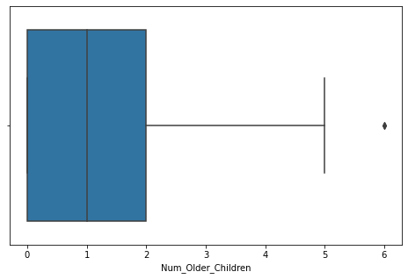

Converting Categories into Codes:

Column: Holiday_Package

[no, yes]

Categories (2, object): [no, yes]

[0 1]

Column: Foreign

[no, yes]

Categories (2, object): [no, yes]

[0 1]

Splitting the data into train and test sets for the LDA model

After assigning the Target variable to ‘Y’ and the independent variables to ‘X’, we split the data into train and test set in 70:30 ratio using train_test_split from sklearn.model_selection.

Checking the head of X_train:

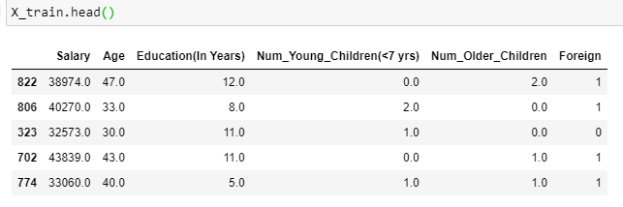

Let's build the LDA Model

Now, we will be building the LDA model and then fit the X_train and Y_train into the model.

Then we will do the train data class prediction and test data class prediction with cut off value 0.5

2.3 Performance Metrics: Check the performance of Predictions on Train and Test sets using Accuracy, Confusion Matrix, Plot ROC curve and get ROC_AUC score for each model Final Model: Compare both the models and write inference which model is best/optimized.

Comparison between train and test Confusion matrix:

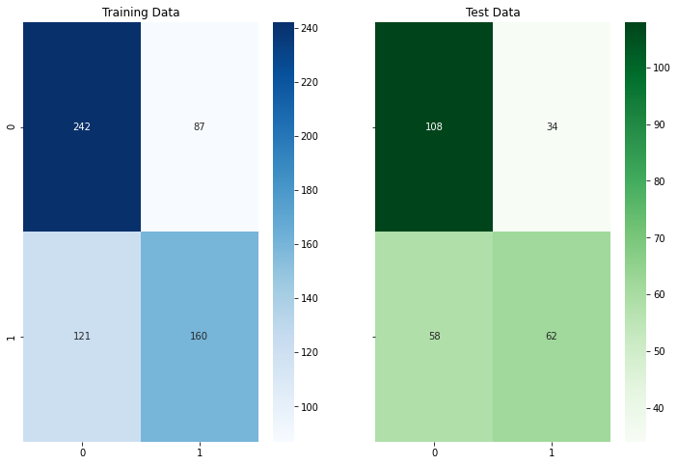

Classification Report comparison

Classification Report of the training data:

precision recall f1-score support

0 0.67 0.74 0.70 329

1 0.65 0.57 0.61 281

accuracy 0.66 610

macro avg 0.66 0.65 0.65 610

weighted avg 0.66 0.66 0.66 610

Classification Report of the test data:

precision recall f1-score support

0 0.65 0.76 0.70 142

1 0.65 0.52 0.57 120

accuracy 0.65 262

macro avg 0.65 0.64 0.64 262

weighted avg 0.65 0.65 0.64 262

AUC and ROC:

AUC for the Training Data: 0.731

AUC for the Test Data: 0.713

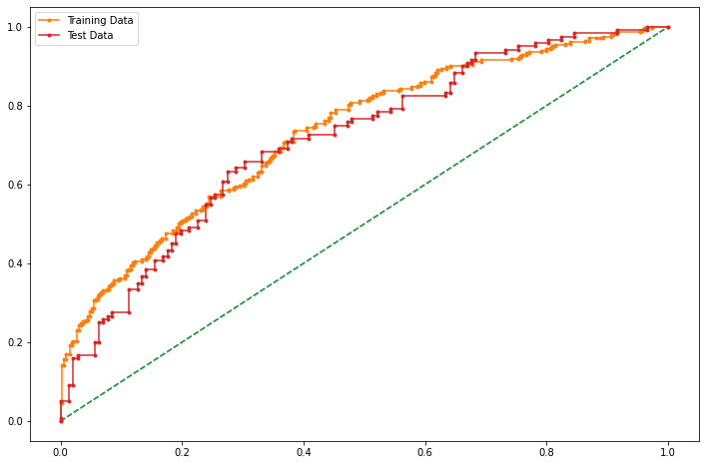

CONCLUSION:

The model accuracy on the training data is 66% and for the testing data is about 65%. This model is affected by a class imbalance problem.

We will build the model again with different cut off values to get the better accuracy.

For cut-off 0.1:

Accuracy Score 0.4738

F1 Score 0.6356

Confusion Matrix

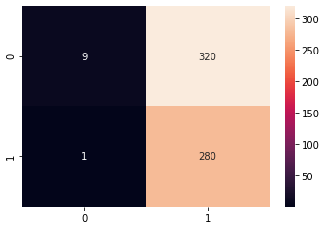

For cut-off 0.2:

Accuracy Score 0.523

F1 Score 0.6498

Confusion Matrix

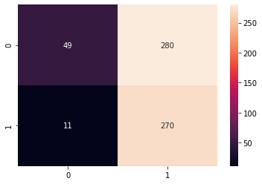

For cut-off 0.3:

Accuracy Score 0.6066

F1 Score 0.6774

Confusion Matrix

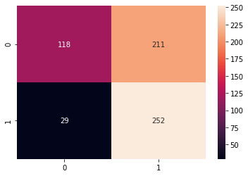

For cut-off 0.4:

Accuracy Score 0.6607

F1 Score 0.6667

Confusion Matrix

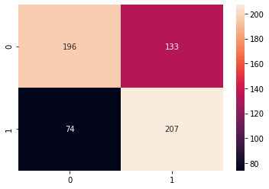

For cut-off 0.5:

Accuracy Score 0.659

F1 Score 0.6061

Confusion Matrix

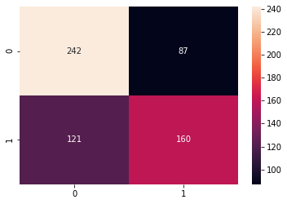

For cut-off 0.6:

Accuracy Score 0.6525

F1 Score 0.5225

Confusion Matrix

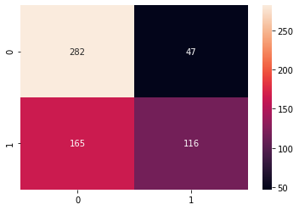

For cut-off 0.7:

Accuracy Score 0.6443

F1 Score 0.4304

Confusion Matrix

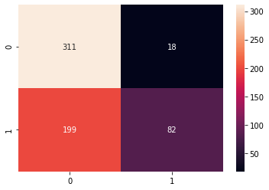

For cut-off 0.8:

Accuracy Score 0.5902

F1 Score 0.2038

Confusion Matrix

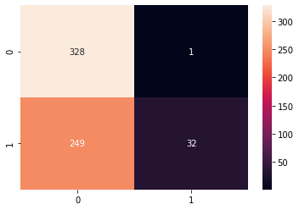

For cut-off 0.9:

Accuracy Score 0.5426

F1 Score 0.0141

Confusion Matrix

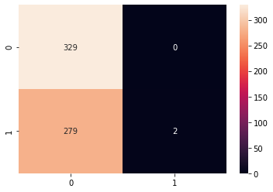

CONCLUSIVE OBSERVATION:

We can see that for 0.3 and 0.4 cut-off value model is giving better accuracy than the rest of the custom cut-off values.

But with the 0.3 cut-off value, model gives us the best 'f1-score' also.

F1 score at cut-off value 0.3 is around 0.68.

Here, we will take the cut-off as 0.3 to get the optimum 'f1' score.

Let us evaluate the predictions of the test data using these cut-off values

Predicting the classes on the test data:

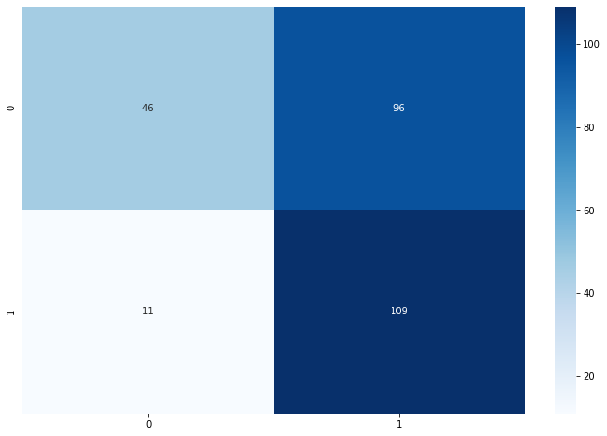

Classification Report of the default cut-off test data:

precision recall f1-score support

0 0.65 0.76 0.70 142

1 0.65 0.52 0.57 120

accuracy 0.65 262

macro avg 0.65 0.64 0.64 262

weighted avg 0.65 0.65 0.64 262

Classification Report of the custom cut-off test data:

precision recall f1-score support

0 0.81 0.32 0.46 142

1 0.53 0.91 0.67 120

accuracy 0.59 262

macro avg 0.67 0.62 0.57 262

weighted avg 0.68 0.59 0.56 262

As we can see accuracy is almost the same, but f1 score is better in LDA model.

2.4 Inference: Basis on these predictions, what are the insights and recommendations.

Insights and Observations:

As per the statistics we get from exploratory data analysis, we can see that aged people are not interested in holiday package and young people are opting for more holiday trips.

We can see from the holiday vs salary plot that the employees with the salary less than 150000 have always opted for the holiday package in comparison with the employees with salary greater than 150000.

Employees with 8 to 12 years of formal education with salary between 250000 to 600000 took more holiday package among all others.

Age, Salary and years of education of the employees are the crucial features in the role of prediction.

The Logistic regression model performs better in terms of Accuracy than that of LDA model, but LDA model gives best f1 score around 0.66 and that is much better than that of logistic regression model, a good F1 score means that we have low false positives and low false negatives.

Recommendation:

Employees having young children less than 3 are more to opt for holiday packages but employees having older children are not going for holidays, so we can provide them family trip tour packages with the combination of places including hill stations and spiritual places, so that the parents and their children both can take the package into consideration and can plan their trip.

Employees with salary above than 150000 seems to be more busy with their work or with their business, so I recommend that we should give them a short holiday trip packages or weekend trip packages which includes some nearby places so that they can think about planning a small holiday trip with their loved ones or with their friends.

Obviously they might be older in the age, so we can add spiritual or holy places like some famous temples in their state, and also we can provide some special concessions to attract them.

We can also understand from the insights we got from the dataset that the employees which falls under the category of age group 25 years to 45 years are more curious and adventurous and also capable to manage their financial conditions better than the employees of the age group more than 50 years, so my recommendations to attract such employees more that we can offer them holiday trip package which includes some attractive places like beach, waterfalls, tracking. We can also add some water sport activities or resorts with night staying facilities.

We can also provide them the pre-booking offers for packages which include some special events that occurs every year.

__ THE END __

